**Ex No: 8**

**Date:**

**GENERATE THREE ADDRESS CODES**

**AIM:**

To generate three address code using C program.

**ALGORITHM:**

* Get address code sequence.
* Determine current location of 3 using address (for 1st operand).
* If the current location does not already exist, generate move (B, O).
* Update address of A (for 2nd operand).
* If the current value of B and () is null, exist.
* If they generate operator () A, 3 ADPR.
* Store the move instruction in memory.

**PROGRAM**:

#include<stdio.h>  
#include<string.h>  
#include<stdlib.h>  
void pm();  
void plus();  
void divi();  
int i,ch,j,l,addr=100;  
char ex[10], exp0[10] ,exp1[10],exp22[10],id1[5],op[5],id2[5];  
char *strrev(char *str){  
      char *p1, *p2;  
      if (! str || ! *str)  
            return str;  
      for (p1 = str, p2 = str + strlen(str) - 1; p2 > p1; ++p1, --p2){  
            *p1 ^= *p2;  
            *p2 ^= *p1;  
            *p1 ^= *p2;  
      }  
      return str;

}  
void main(){  
while(1){  
printf("\n1.assignment\n2.arithmetic\n3.relational\n4.Exit\nEnter the choice:");  
scanf("%d",&ch);  
switch(ch){  
case 1:  
printf("\nEnter the expression with assignment operator:");  
scanf("%s",exp0);  
l=strlen(exp0);  
exp22[0]='\0';  
i=0;  
while(exp0[i]!='=')  
 i++;  
strncat(exp22,exp0,i);  
strrev(exp0);

exp1[0]='\0';  
strncat(exp1,exp0,l-(i+1));  
strrev(exp1);  
printf("Three address code:\ntemp=%s\n%s=temp\n",exp1,exp22);  
break;  
case 2:  
printf("\nEnter the expression with arithmetic operator:");  
scanf("%s",ex);  
strcpy(exp0,ex);  
l=strlen(exp0);  
exp1[0]='\0';  
for(i=0;i<l;i++){  
if(exp0[i]=='+'||exp0[i]=='-'){  
if(exp0[i+2]=='/'||exp0[i+2]=='*'){  
pm();  
break;}  
else{

plus();  
break;}  
}  
else if(exp0[i]=='/'||exp0[i]=='*'){  
divi();  
break;}  
}  
break;  
case 3:  
printf("Enter the expression with relational operator");  
scanf("%s%s%s",id1,op,id2);  
if(((strcmp(op,"<")==0)||(strcmp(op,"&gt;")==0)||(strcmp(op,"<=")==0)||(strcmp(op,"&gt;=")==0)||(  
strcmp(op,"==")==0)||(strcmp(op,"!=")==0))==0)  
printf("Expression is error");  
else{  
printf("\n%d\tif %s%s%s goto %d",addr,id1,op,id2,addr+3);  
addr++;  
printf("\n%d\t T:=0",addr);  
addr++;  
printf("\n%d\t goto %d",addr,addr+2);  
addr++;  
printf("\n%d\t T:=1",addr);  
}  
break;  
case 4:  
exit(0);  
}  
}  
}  
void pm(){  
strrev(exp0);  
j=l-i-1;  
strncat(exp1,exp0,j);  
strrev(exp1);  
printf("Three address code:\ntemp=%s\ntemp1=%c%ctemp\n",exp1,exp0[j+1],exp0[j]);  
}  
void divi(){  
strncat(exp1,exp0,i+2);  
printf("Three address code:\ntemp=%s\ntemp1=temp%c%c\n",exp1,exp0[i+2],exp0[i+3]);  
}  
void plus(){  
strncat(exp1,exp0,i+2);  
printf("Three address code:\ntemp=%s\ntemp1=temp%c%c\n",exp1,exp0[i+2],exp0[i+3]);  
}

**OUTPUT:**

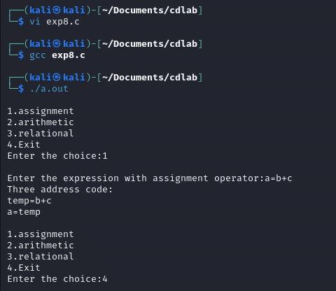

**RESULT:**

Thus, three address code is generated using C program.